Admin username- admin

Admin pw- admin123

Librarian username- shikhar

Librarian pw-shikhar123

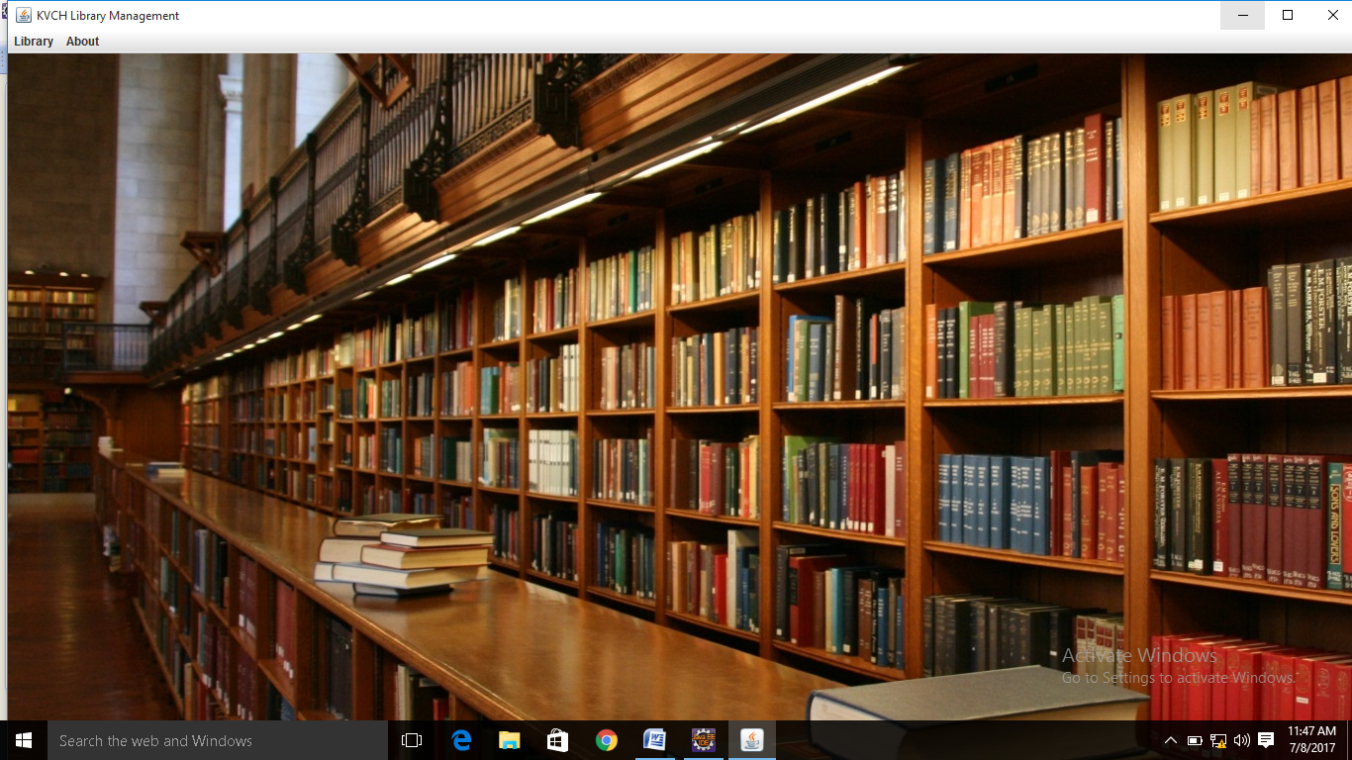

This is the home page. Click on the **Library** menu and two options will open**. Admin Login** and **Librarian Login.**

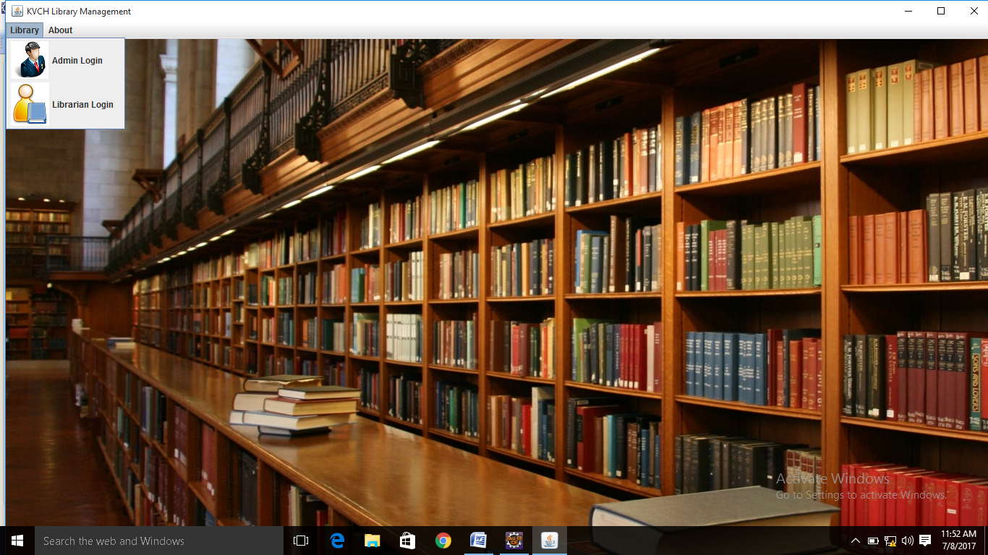

Click on **Admin Login** to enter as Admin.

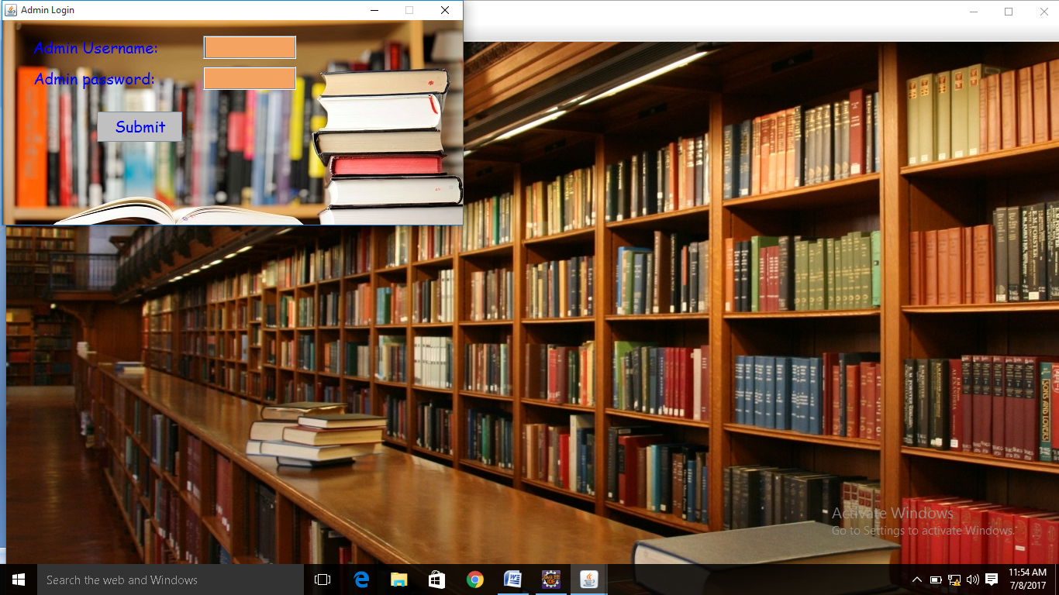

Enter **admin** as username and **admin123** as password. You will enter the admin page.

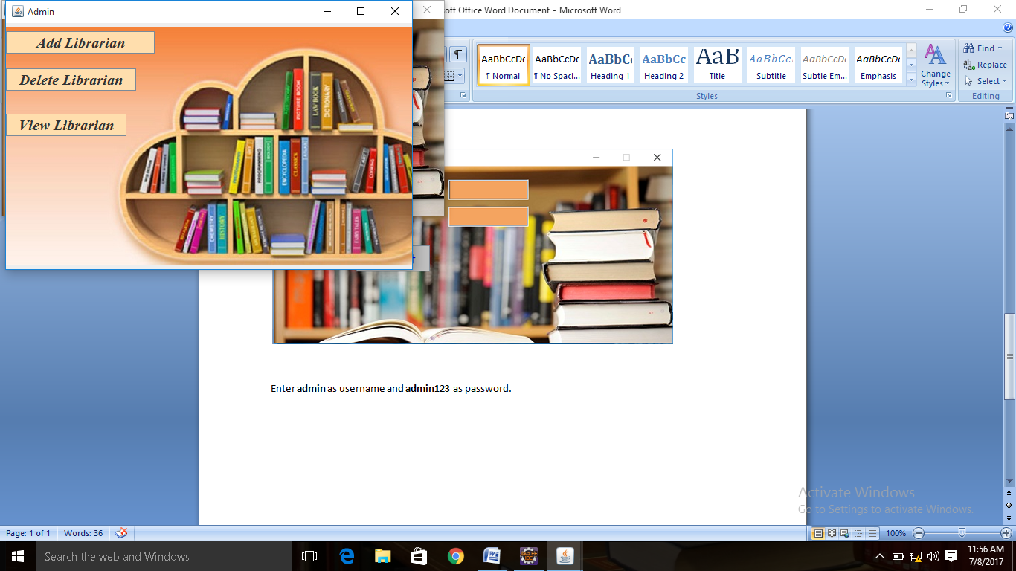

Click on **Add Librarian.** Fill out the form and submit.

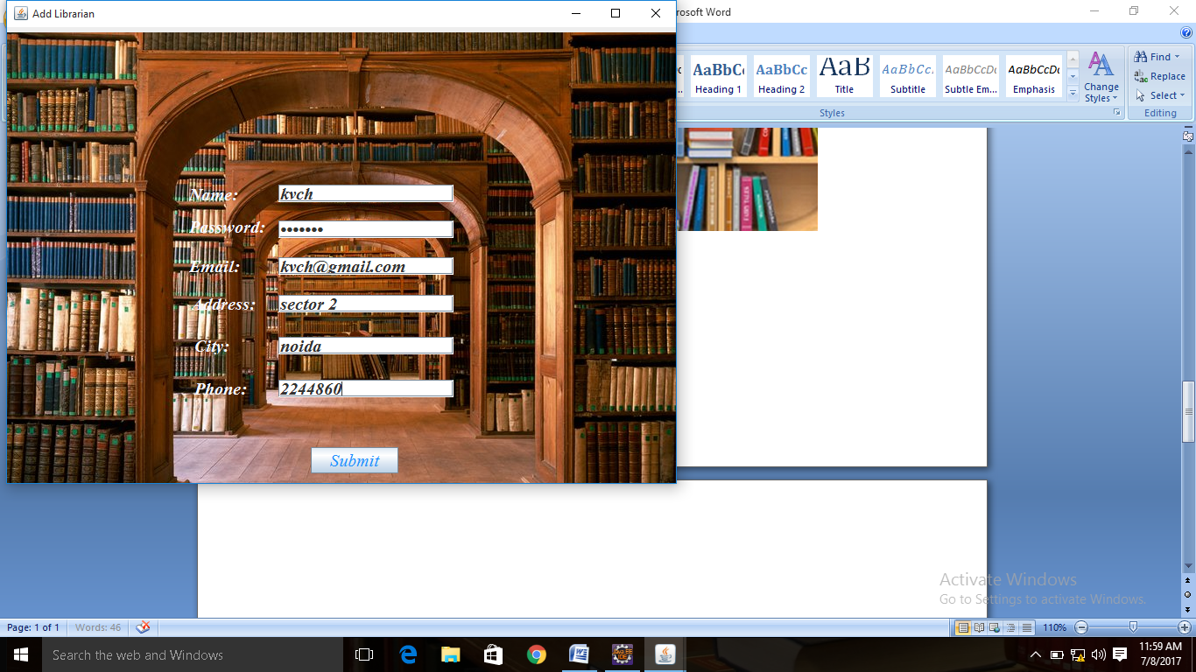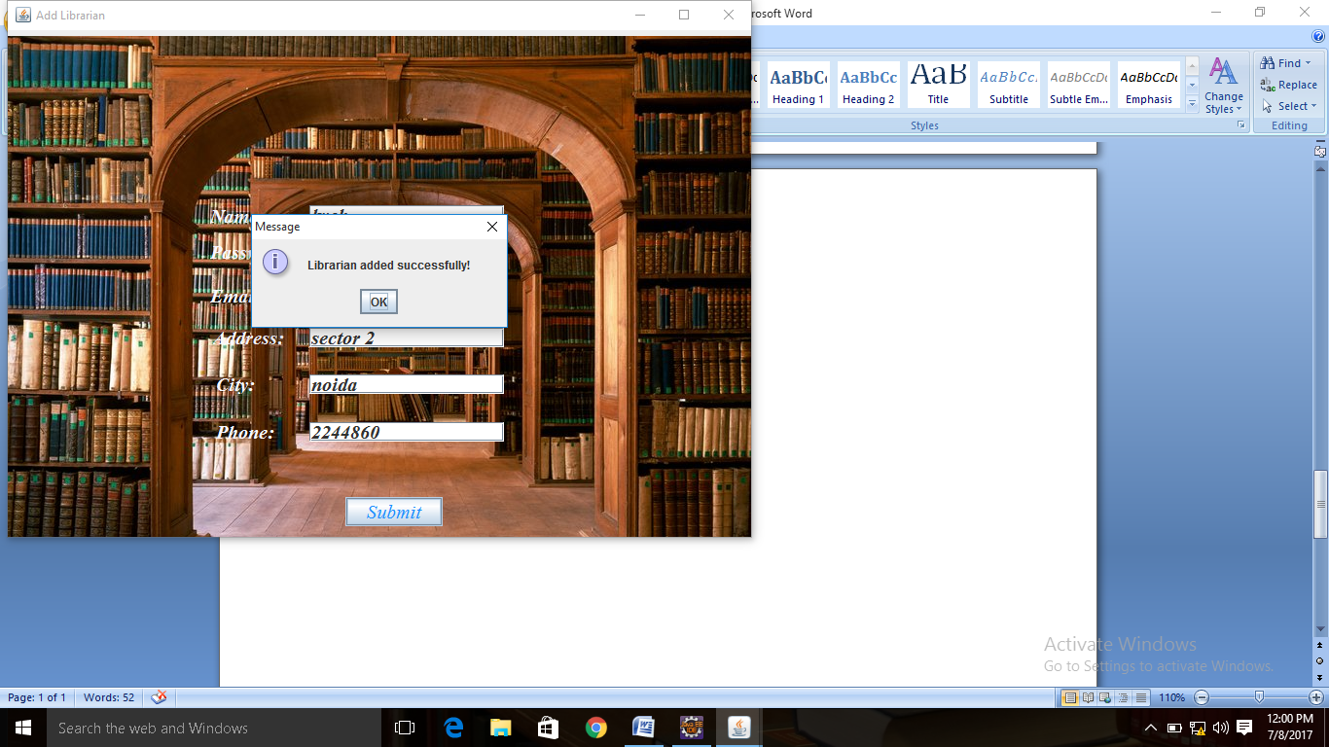

Now back to the Admin page and click View librarian. Librarian has been added.

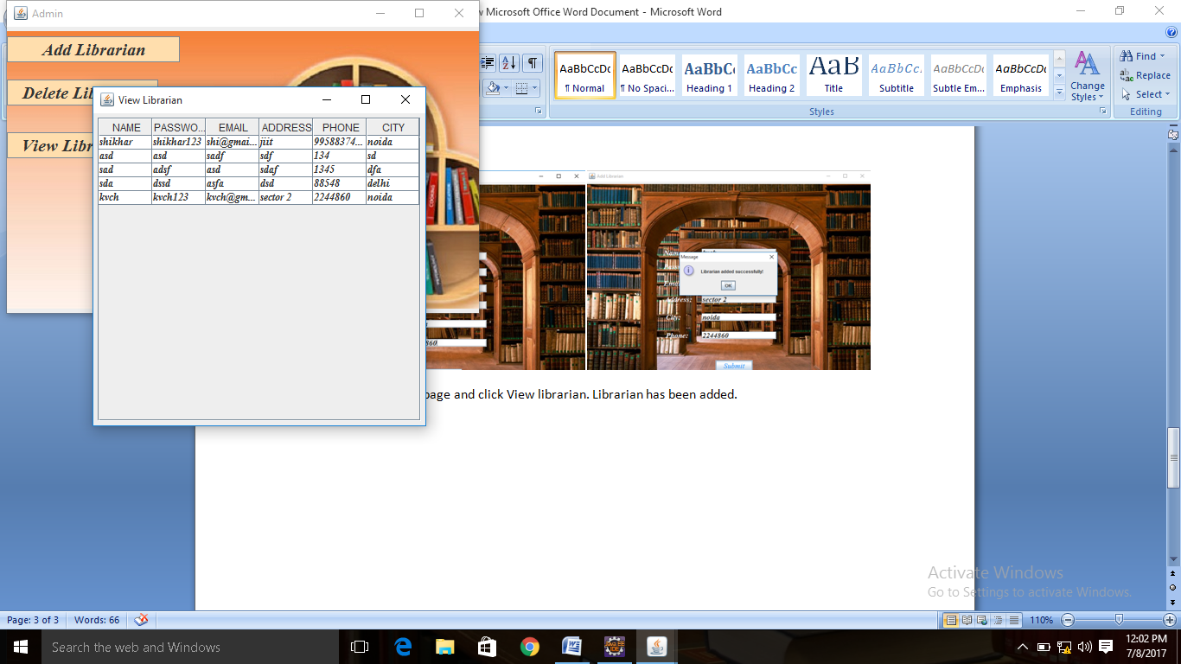

Now go to **delete librarian**. enter details and press **delete**. Go to **View librarian** to see record has been deleted.

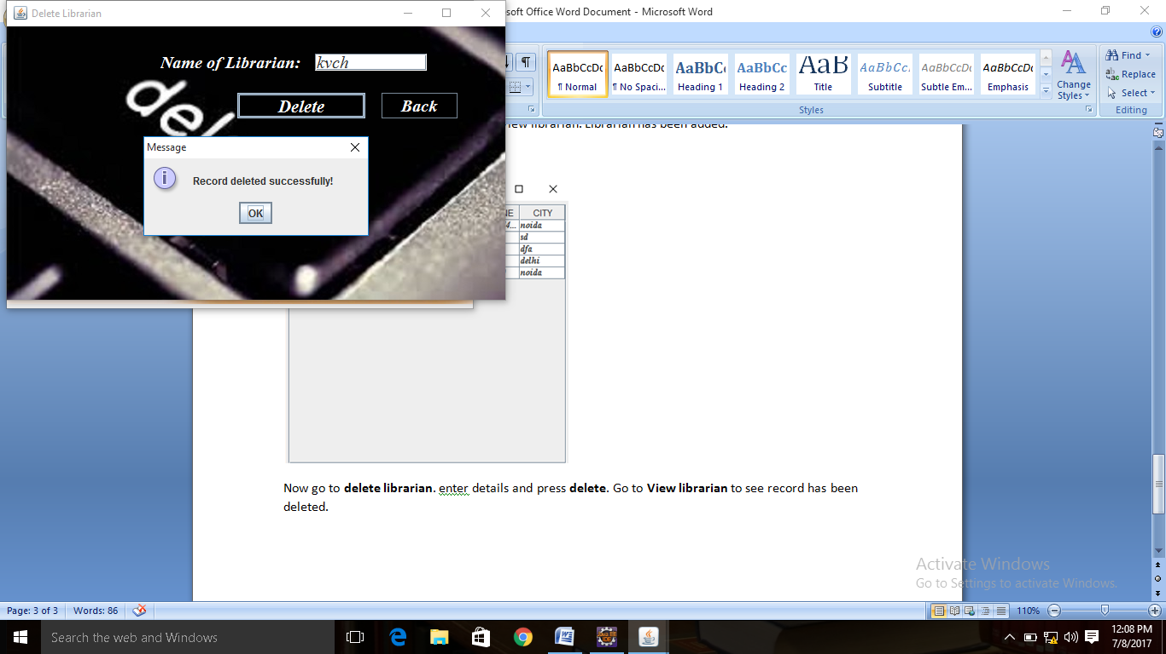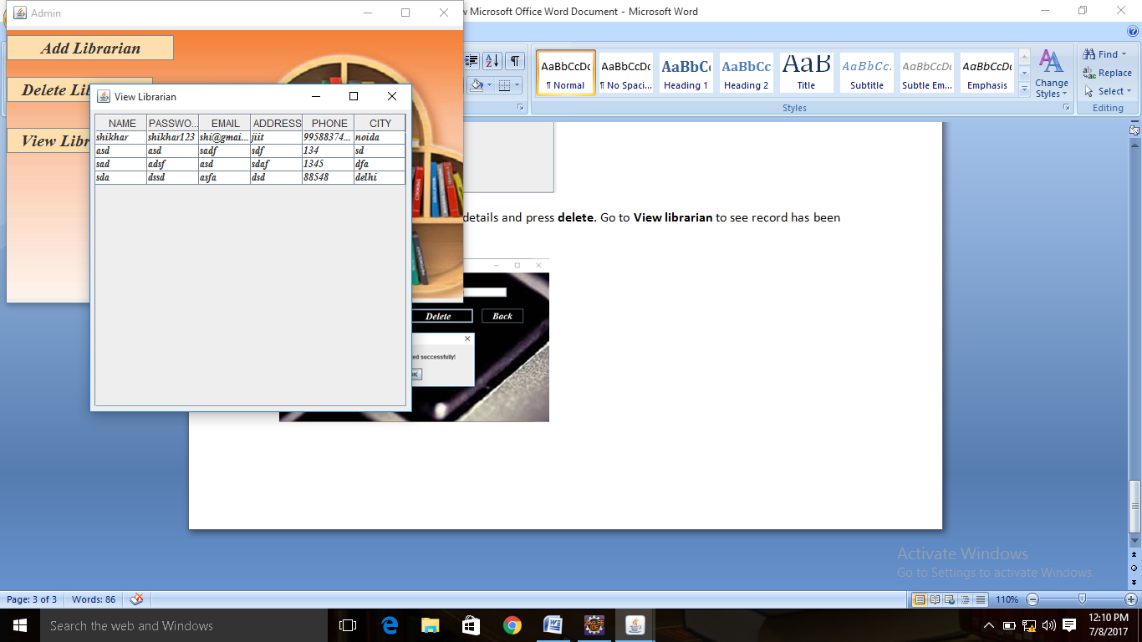

Now go to **Home** page and go to **Librarian Login**. Enter details.

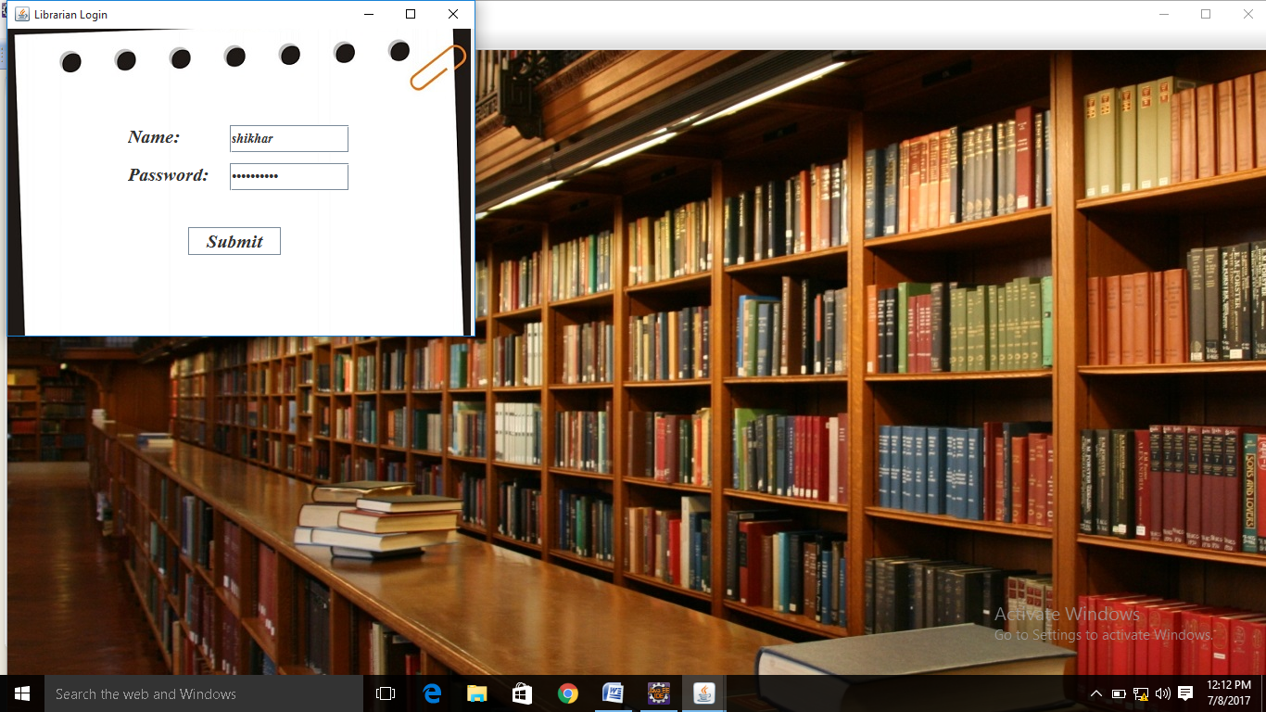

Submit. Wrong details will give error message.

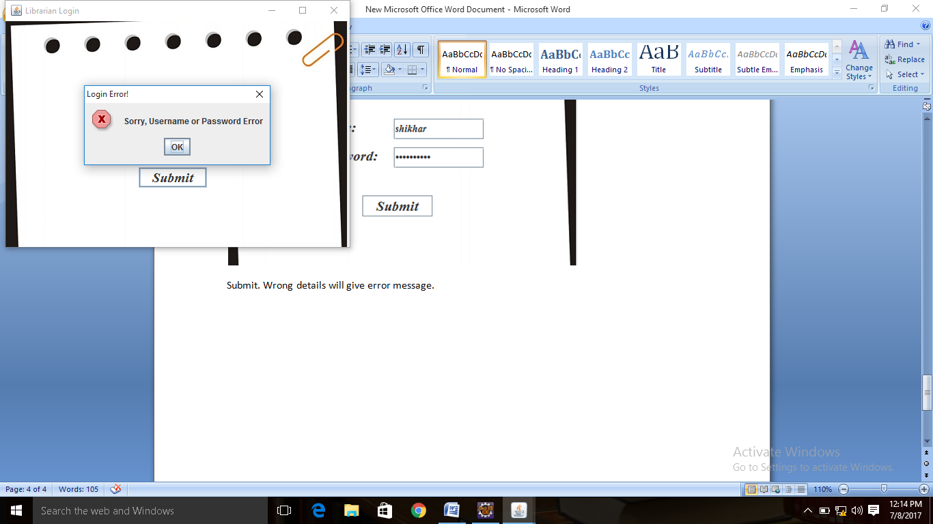

Filling right details, we will enter the Librarian page. Enter **shikhar** and **shikhar123**

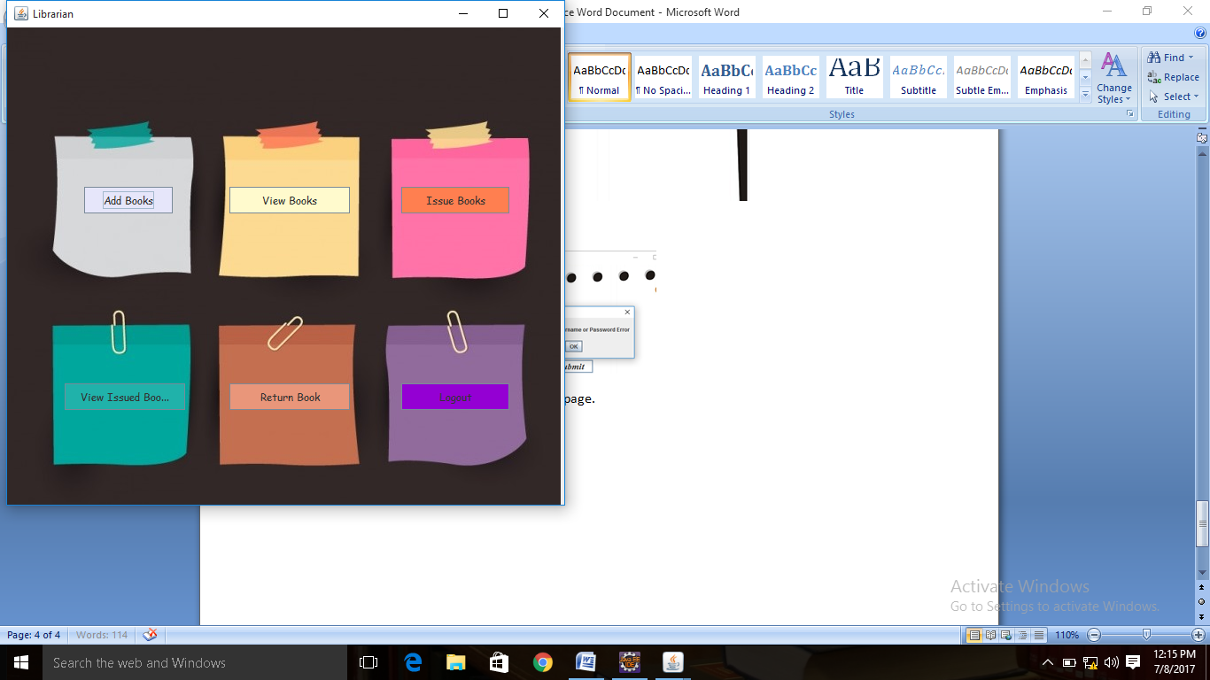

Go to **Add Books**.

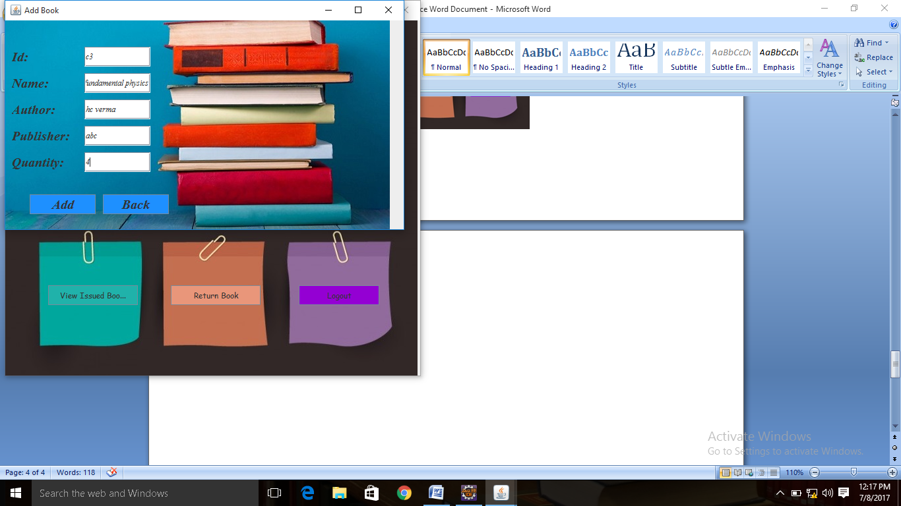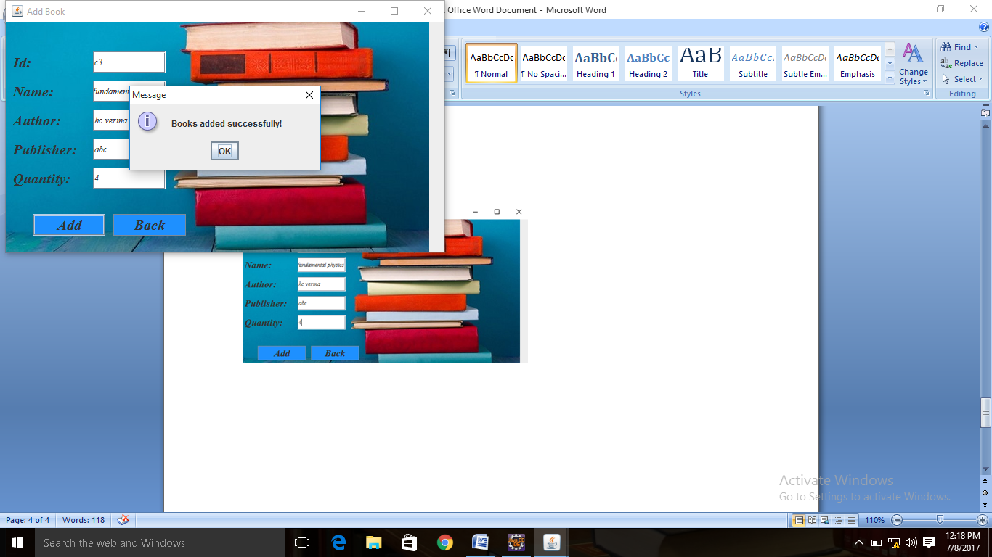

Go to **View Books.**

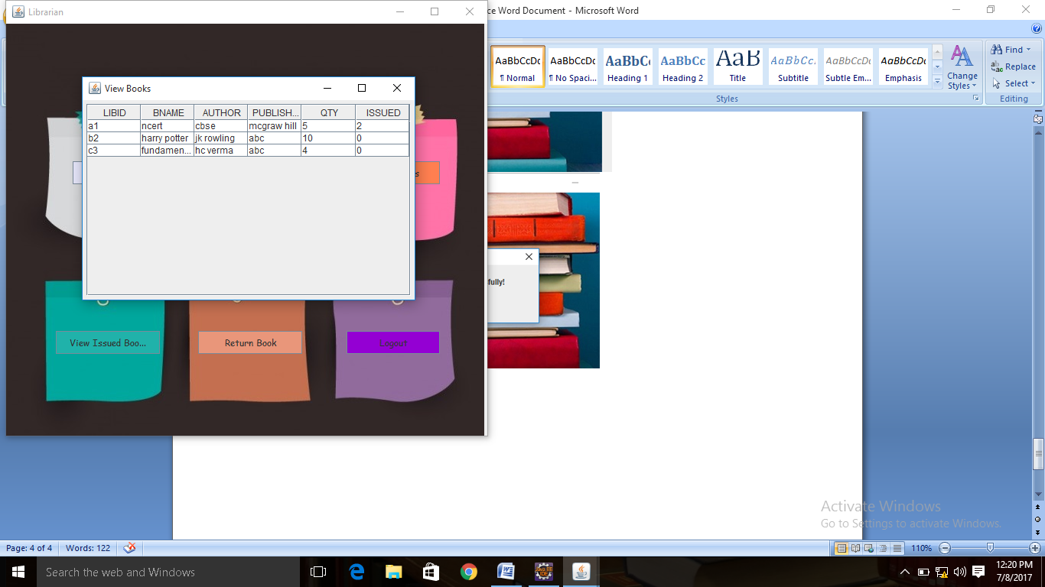

Go to **Issue Books**. Enter details and submit. It will only submit if book id is valid.

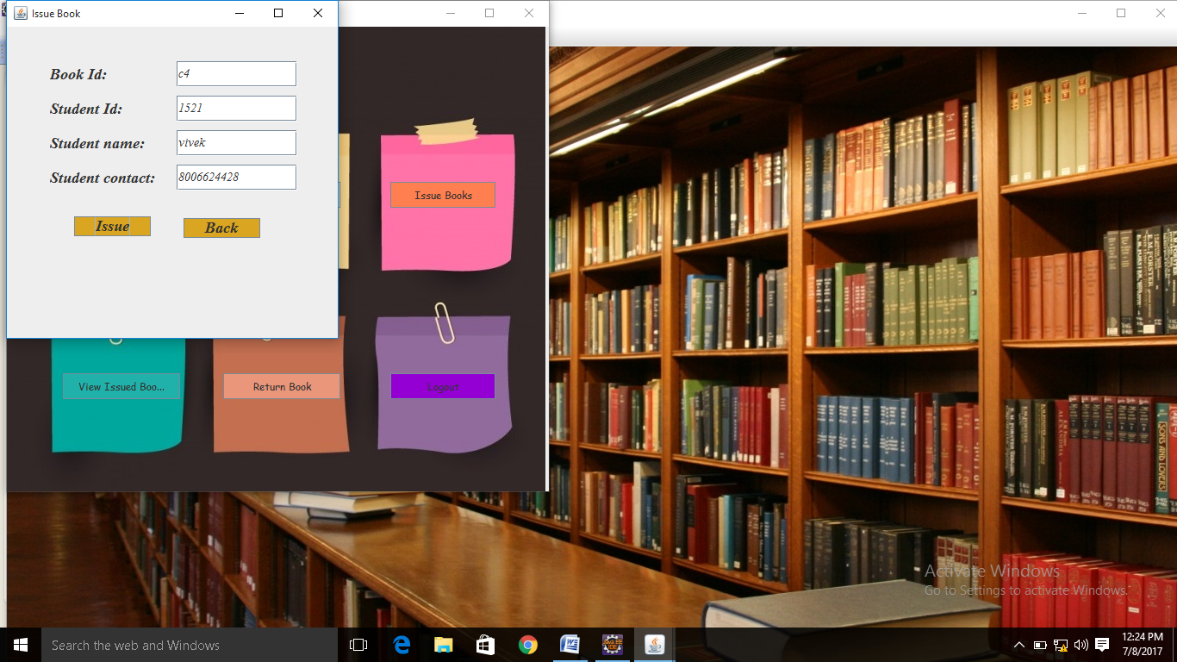 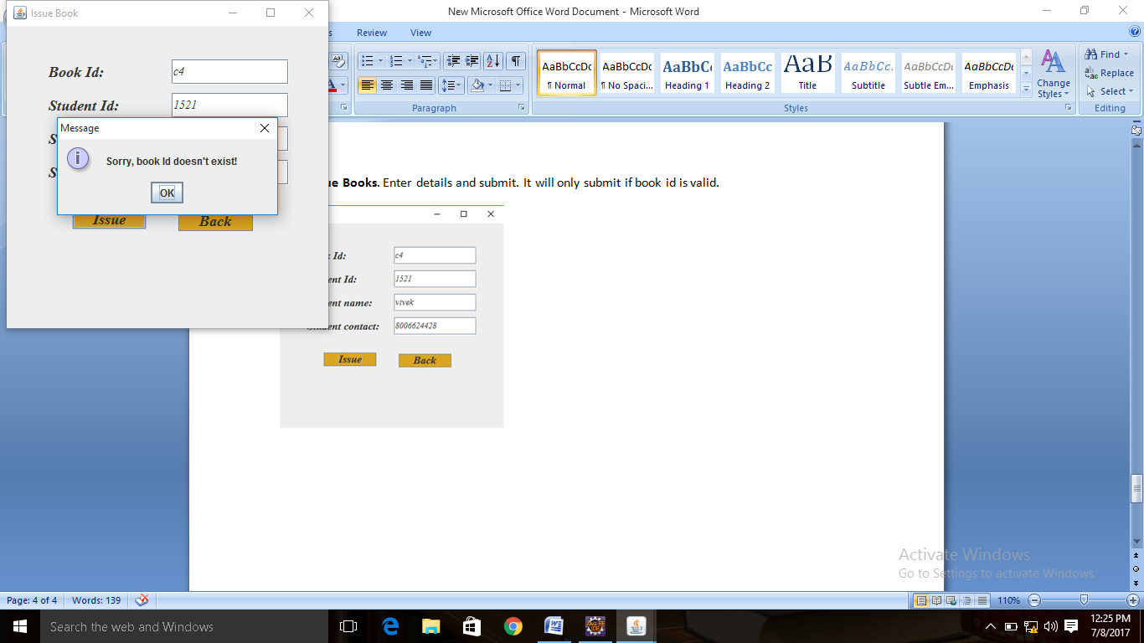

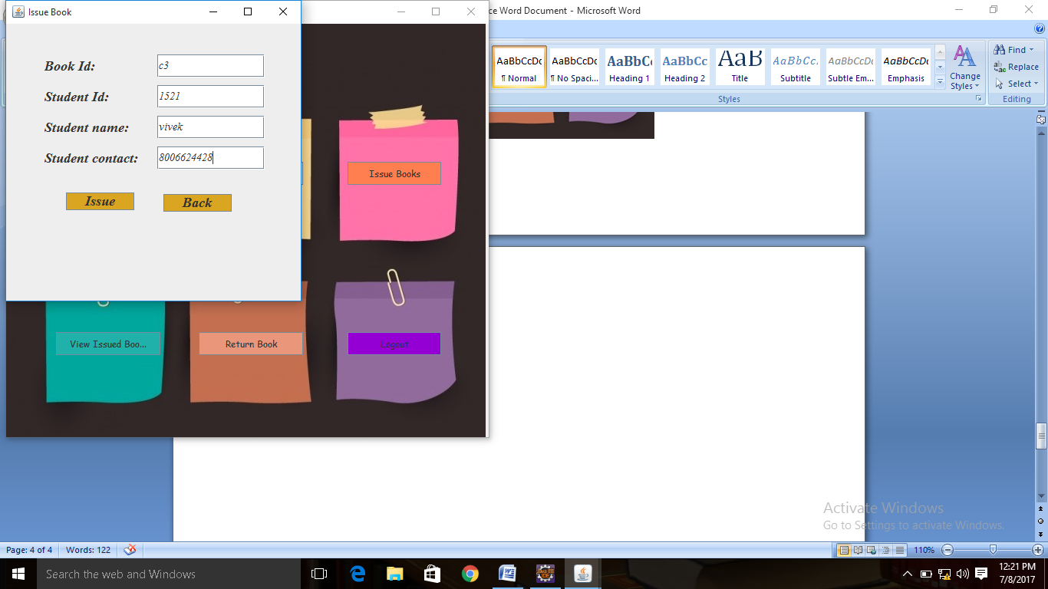 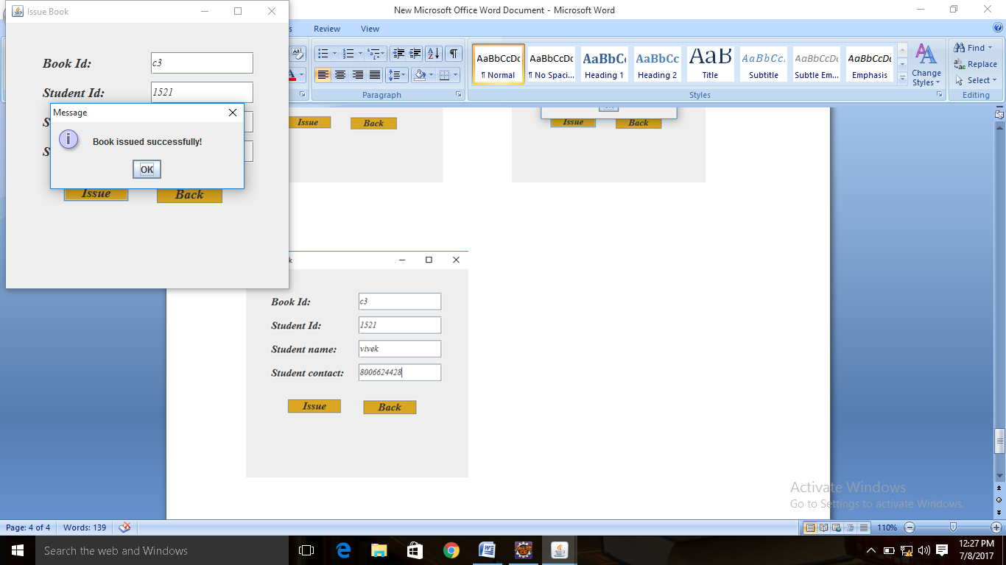

Go to **View Issued Books.**

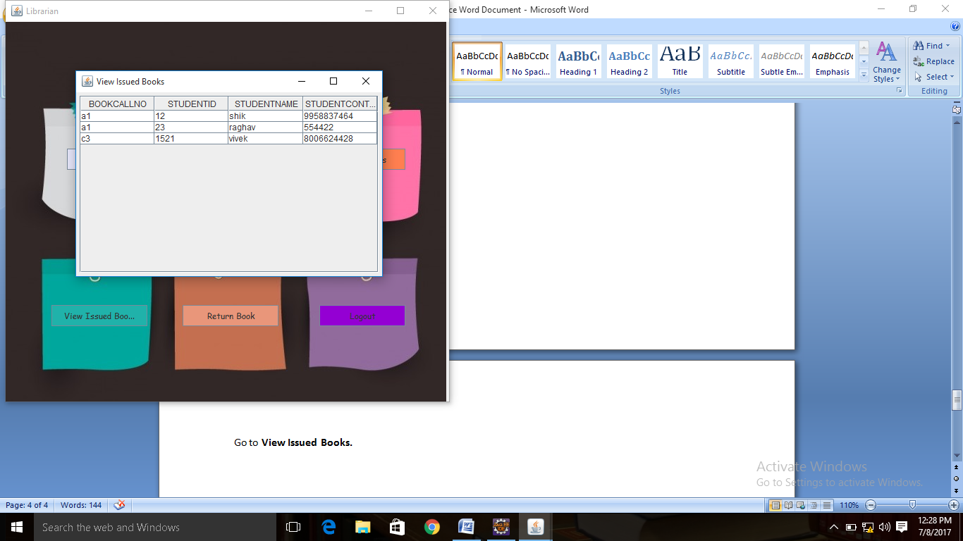

**Also check the count of issued books. Go to View Books. Qty of c3 has decreased and issue has increased.**

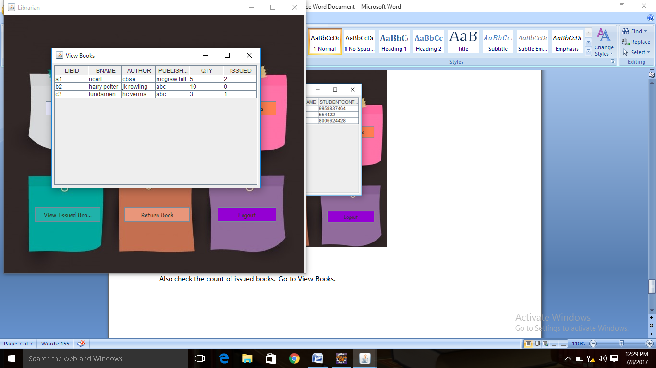

Go to **return books**.

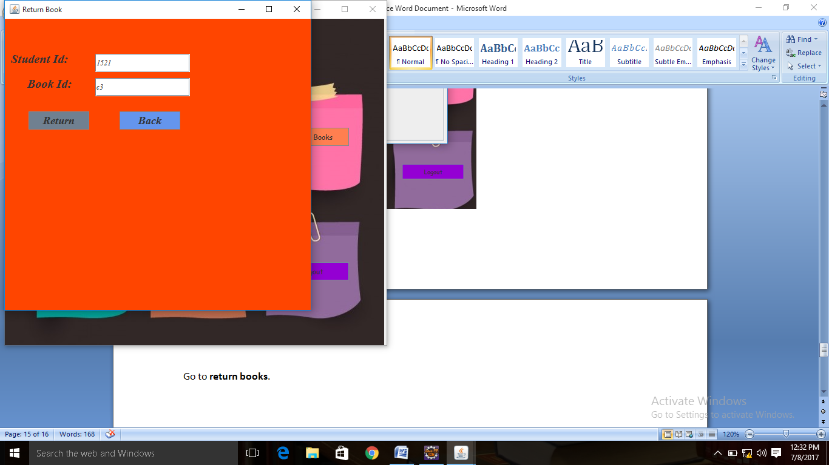 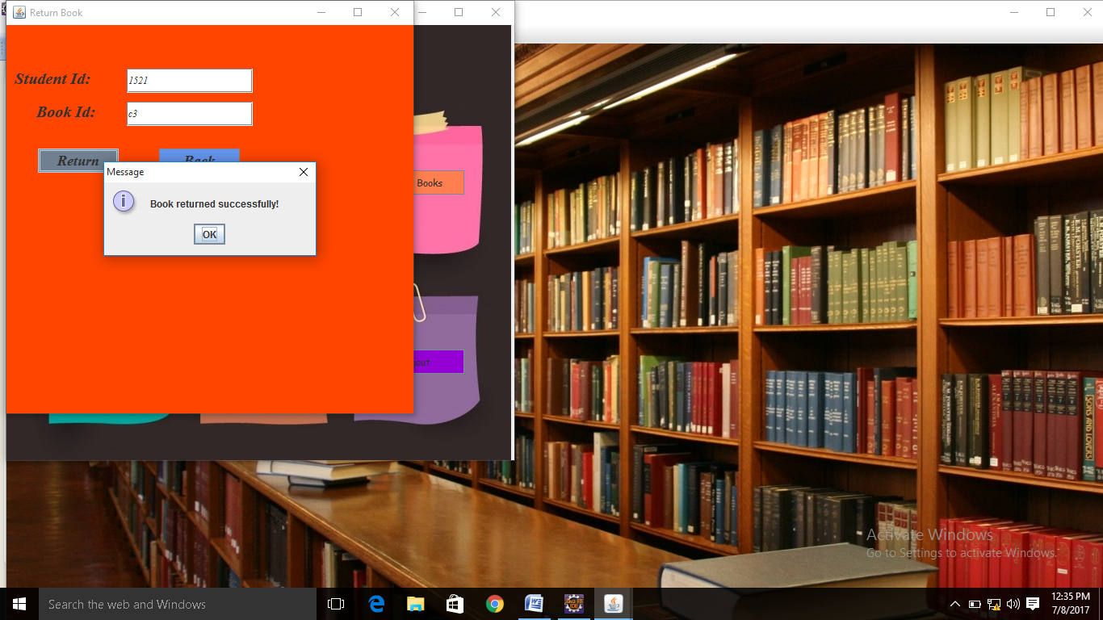

**Now check the view books table to see the updated count.**

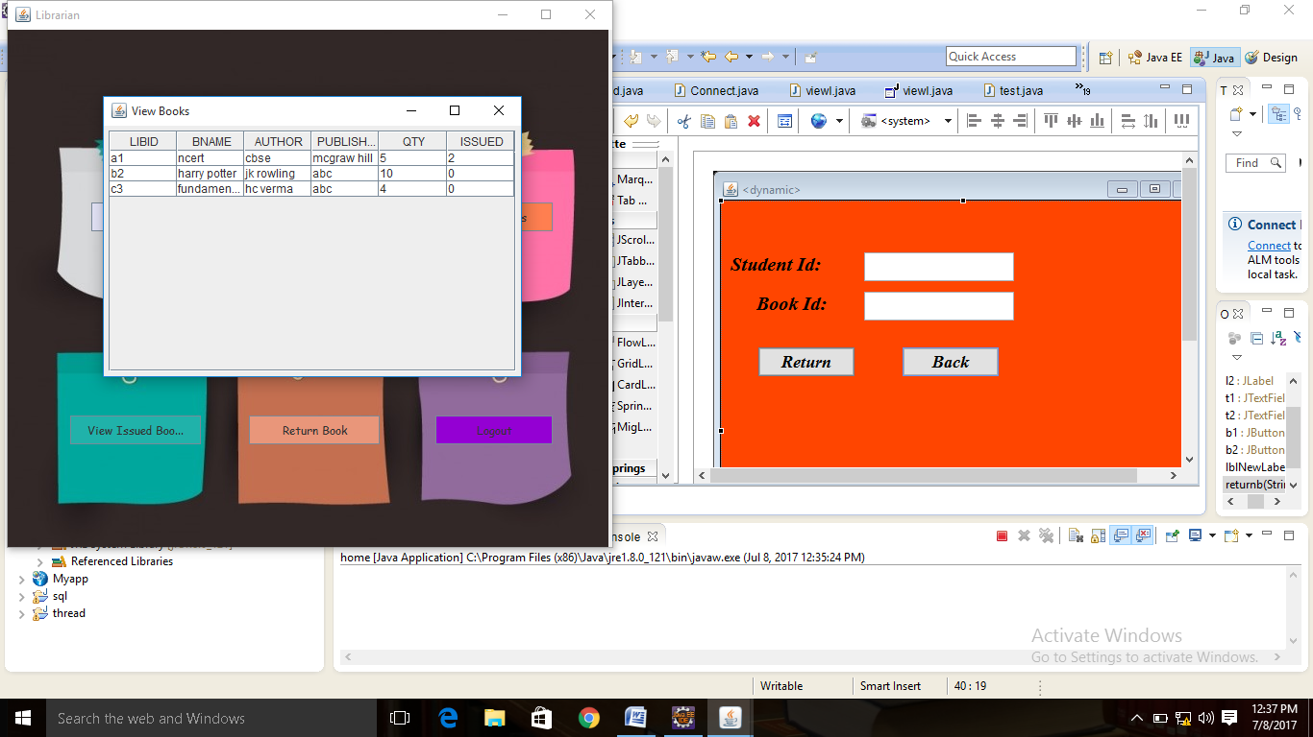

Count is updated. **Logout** to return to home page.

Sql Table schema:-

Books-

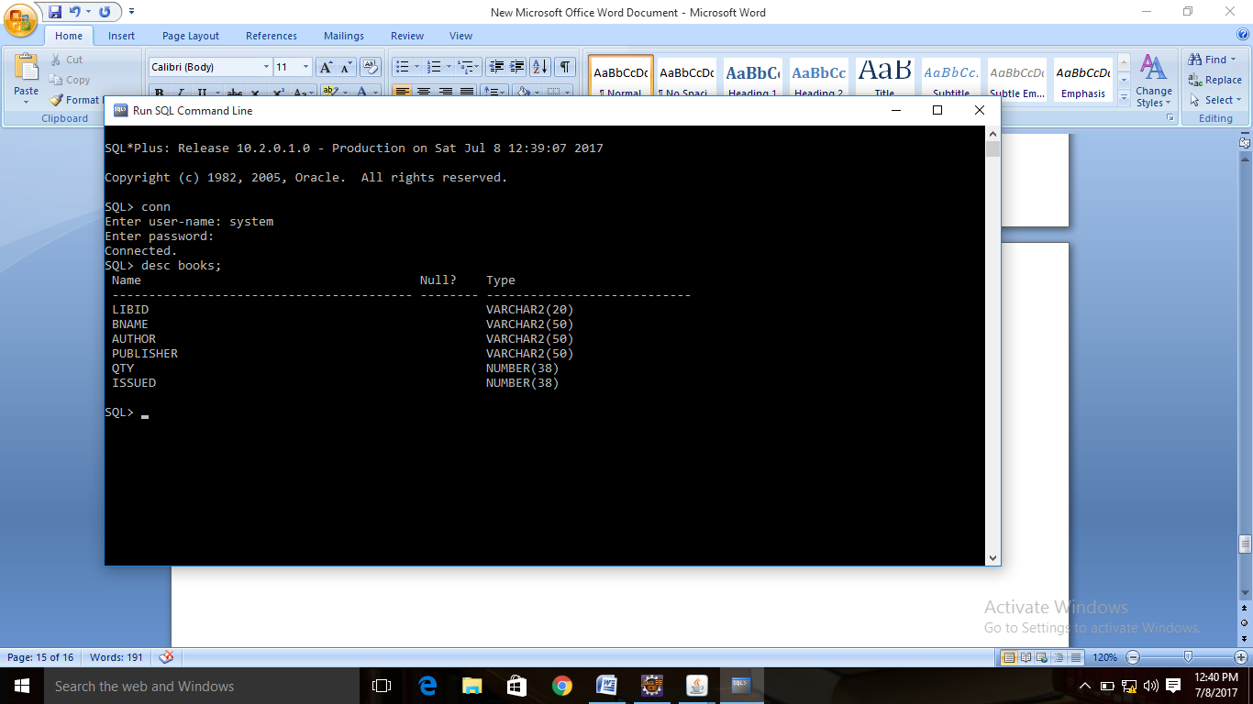

Librarian table named as viewl:-

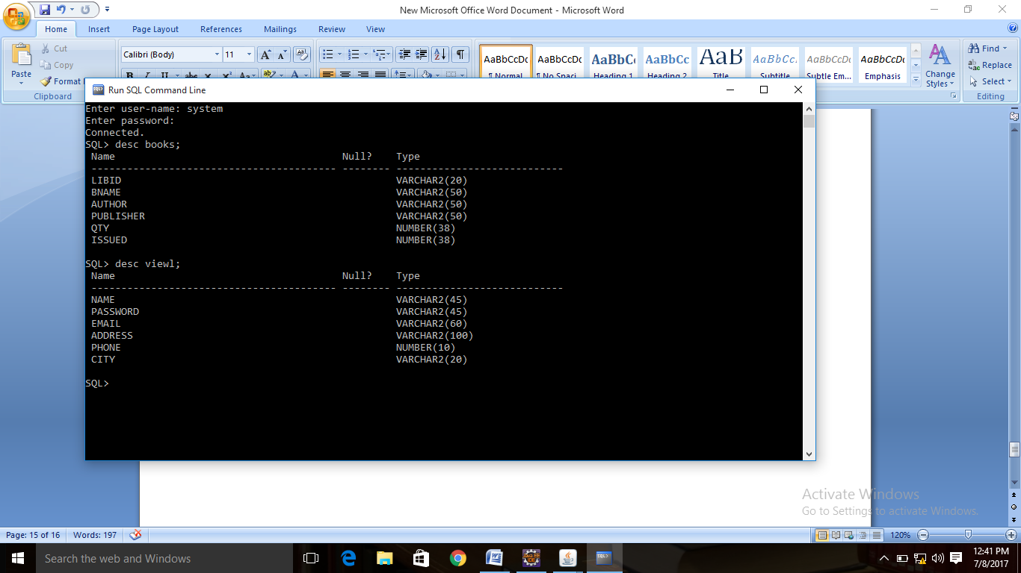

**Issuedbooks-**

